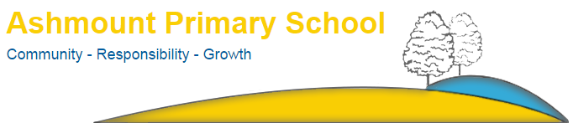

Crouch Hill Park
83 Crouch Hill
LONDON
N8 9EG

Tel: 0207 272 7145
Email: info@ashmount.islington.sch.uk

Parental Agreement for Administration of Medicine in School

Ashmount School has a policy that staff can administer prescribed medication. However, we cannot not give your child medicine unless you complete and sign this form.

Name of Child
Date of Birth
Class
Medical condition

Medicine

Name/Type of Medicine
Expiry Date
Dosage and Method
Timing
Special Instructions
Any side effects?
Self-administration- Y/N
Procedures to be taken in an emergency

NB: Medicines must be in original container as dispensed by the pharmacy.

Contact Details

Name
Telephone Number(s)
Relationship to Child
Address

The above information is, to the best of my knowledge, accurate at the time of writing and I give consent to the school staff administering medicine in accordance with the school policy. I will inform the school, immediately in writing, if there is any change in dosage or frequency of the medication or if the medicine is stopped.

Signature ………………………………………………………………………… Date…………………………………

