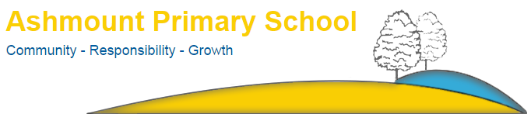

Crouch Hill Park
83 Crouch Hill
LONDON
N8 9EG

Tel: 0207 272 7145
Email: info@ashmount.islington.sch.uk

20th July 2021

WALKING BUS

Dear Parents and Carers,

If you would like to use the Walking Bus to the Cape adventure playground, as a result we are now asking for families to sign-up to the service.
Children must be signed the bus up in HALF TERMLY BLOCKS. We can no longer accept on the day calls/emails.

Please note:
- Parents and carers of children in Years 1-4 can sign up.
- Children must be registered with The Cape already
www.awesomeadventureplay.org
- If your child does not need the service for any reason on any day, please email: walkingbus@ashmount.islington.sch.uk
- We will only be walking over once a day at 3.45pm so if your child attends a club it is your responsibility to get them to the Cape if you so desire.
- The service is free

Please fill in the slip below to confirm the days you would like your child to be taken to the Cape at 3.45pm. You can email the form to walkingbus@ashmount.islington.sch.uk.

King regards

Anthony Carmel
Head teacher

Name of child:_______________________________________________

Year group: _________________________________________________

Tick days walking bus is required:
Mon: | Tue: | Wed: | Thur: | Fri:

Term dates: week commencing: 6th September.

PERMISSION TO TRAVEL HOME/CAPE INDEPENDENTLY
YEARS 5/6 academic year 2021-2022

I hereby give permission for my child ……………………………………………………………………………… DOB…………………………………… in class…………………………………. to travel HOME/CAPE (delete appropriately) and accept full responsibility for making their own journey to their destination independently.

Signature of Parent/Guardian: …………………………………………………………………………………………………………………………….

Date: ……………………………………….

Contact number: ………………………………………………………………………………

NB: please email completed form to walkingbus@ashmount.islington.sch.uk

Headteacher: Anthony Carmel

