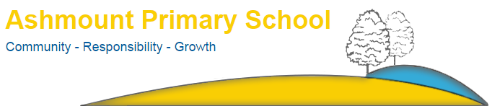

Crouch Hill Park
83 Crouch Hill
LONDON
N8 9EG

Tel: 0207 272 7145
Email: info@ashmount.islington.sch.uk

LEAVERS FORMS
Please complete this form and return to the school office.

NAME
CLASS
PRESENT ADDRESS
NEW ADDRESS
TELEPHONE NUMBER
MOBILE NUMBER

NAME OF NEW SCHOOL
ADDRESS OF NEW SCHOOL
LAST DAY AT ASHMOUNT PRIMARY SCHOOL
SIGNATURE
DATE

Headteacher: Anthony Carmel

